OPENARTEXCHANGE - OPENING EXHIBITION THE UNEXPECTED UNIVERSE

From Saturday 10 July, the solo exhibition 'The unexpected universe' with paintings and collages by Sanda Amadou (Benin) can be seen. During the festive walk-in afternoon on Saturday 10 July from 14:00, we will provide a snack and a drink during your visit. The exhibition can be visited until 5 September, during which time we are closed during the summer holidays from 4 to 25 August.

About The unexpected universe

The unexpected universe is a largely black and white world with a tinge of color, somewhere between reality and fantasy. With his unique semi-abstract visual language, Amadou reinterprets the nomadic Fulani universe and brings it to life. A dream world formed by various entwined and sometimes overlapping elements (ropes, lianas, knots, leaves, circles and other patterns from the ancient Fulani tattoos), telling about humanism, resistance, tenacity, resilience, courage, freedom and some other observations.

His works seem to obey a rigorous geometry and form complex architectures, which are simultaneously playful and surprisingly fragile. Lines, circles, triangles and quadrilaterals, semi-mathematical figures that are never perfect, connect Fulani symbols of natural life with ropes at the base. His images result in imaginary forms and grotesque figures that show a ragged vulnerability, ethereal and always in motion. They allow the viewer to glimpse an unreal essence.

About Sanda Amadou

Sanda Amadou was born and raised in 1978 in a Fulani community in Northern Benin. He holds a PhD in Sociolinguistics (University of Ghana, Accra) and received his visual education through residencies and master workshops. He lived and worked in Lagos for several years, but returned to Cotonou, Benin in 2019. From his early childhood he drew, fascinated by the culture of the nomadic Fulani, which he still studies and reinterprets in his work.

Amadou is recognized both domestically and internationally. He has participated in many solo and collective exhibitions over the years, including in Benin Republic, Ghana, Nigeria, South Africa, Senegal, Dubai, Germany, Netherlands and USA (San Francisco, New York) and has been featured at major international art exhibitions and fairs such as World Art Dubai and at ARTX Lagos (Nigeria), and later this year at AKAA Paris.

OpenArtExchange

OpenArtExchange is an international art gallery that supports promising non-Western artists and connects them with the Western art and culture world, including through international residencies and exhibitions with local artists from its location in the museum quarter in Schiedam. In addition, she represents her artists at international art fairs, art festivals and other art events and online.

Photo
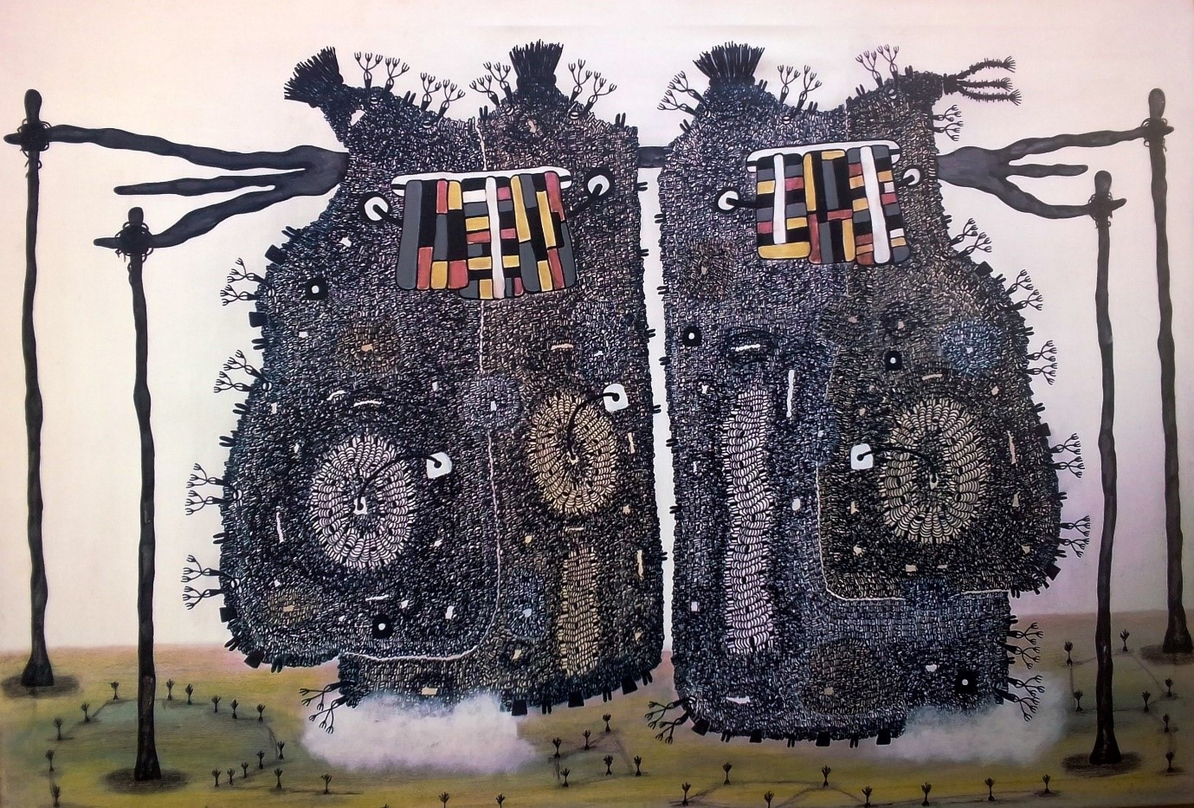

Humanism II, 2021, acrylic, pastels, charcoal and ink on canvas, 90x130cm by Sanda Amadou ©OpenArtExchange

Info

OpenArtExchange
Hoogstraat 85
3111 HC Schiedam
Email: info@openartexchange.com
Website: www.openartexchange.com
Facebook: https://www.facebook.com/openartexchange/
Instagram: https://www.instagram.com/openartexchange/

Opening hours

Wednesday to Saturday: 10:00 am – 6:00 pm
Sunday: 13:00 – 18:00

