OPENARTEXCHANGE - OPENING EXHIBITION REFLUX

On Saturday 18 September we will open the duo exhibition Reflux with paintings and collages by two artists from DR Congo, now working in France: Bouvy Enkobo and Jonathan Vatunga. During the festive walk-in afternoon, you are welcome to be the first to view the exhibition from 14:00. We provide snacks and drinks during your visit. The exhibition is on display until October 24.

About Reflux

The past COVID period has been a period of standstill for many communities, far and near. A standstill that put people under pressure, made vulnerabilities and inequalities visible, and showed the devastating impact our way of life has on our environment. It also created a stand-still in time, that forced us back to the confinement of our homes and families, our close communities and allowed for reflection on our position where to go from here. Reflux is about rethinking the past in view of our present situation and going back to the core human values we need in order to build better societies tomorrow. The literal meaning of a reflux is that it causes a flow back in opposite direction or, in chemistry, it is the process to return vapor back to its a solid state. It’s a very distinct movement of transformational change.

In Reflux, Enkobo and Vatunga examine the question of how we can go back to solid, well-balanced and equitable societies, or were we never quite there? How can we learn from the past, so we can keep and/or return to solid roots without repeating the mistakes we made and adapt to our environment in a sustainable way? Reflux is not about a simple return to a static state but rather a dynamic reflection on conserving the valuable past and embarking on a step change needed for sustainable societies tomorrow.

About Bouvy Enkobo

Bouvy Enkobo (1981) studied at the Academy of Fine Arts in Kinshasa, but left to pursue his career only as part of the 'new wave' generational conflict. In addition to painting, he also experiments with collage, photography and video.

In his new work, Enkobo combines his expressionistic colorful painting style with realistic elements and a unique form of street art collage, in which he is more explicit than ever. He still shows the vulnerable profiles trying to survive in big cities, in a modern world where evolution does not take into account individuals or their values or their natural environment. But this time the abstraction has given way to a face, self-confidence, fighting spirit and determination. In his symbolism he goes back to the African roots, the trauma of colonization, but places this in a contemporary setting and forces his viewers to reflect. There is hope on the horizon.

Enkobo has exhibited in DR Congo, Zimbabwe, South Africa, France, Belgium, the Netherlands and the USA and won the European Union Special Prize at the Yango Biennale in Kinshasa in 2014. His work is included in the collection of the Delegation of the European Union in DR Congo, Fondation Hirondelle and many private collections.

About Jonathan Vatunga

Jonathan Vatunga (1996) graduated from the Academy of Fine Arts in Kinsasha (DRC) in 2017. He received early recognition for his candid paintings and photo collages in his own unique style and symbolism, for which he also paid the bitter price of political refugee a few years later.

Vatunga presents a colorful and dynamic world in constant transformation by shaping its characters through superimposed lines and disintegrating them under the pressure of society. His intriguing collages of photographs and symbolism give a layered meaning to his characters, with their glasses reflecting the inner vision. In Vatunga's world, societies are fragile and disintegrated, "people are destroyed by the people", but he also calls for change. He deconstructs the figure of the human body by showing life being reconstructed, a story being rewritten. A story that sometimes confronts as a cry for an end to suffering and injustice, but also a story that somewhere offers room for resistance, hope and joy. And beauty: alienating how injustice can be beautiful.

Vatunga has participated internationally in many exhibitions in DR Congo, Ivory Coast, Senegal, South Africa, France, Netherlands, Germany and Hong Kong in recent years and has been auctioned in Paris and Brussels.

OpenArtExchange

OpenArtExchange is an international art gallery that supports promising non-Western artists and connects them with the Western art and culture world, including through international residencies and exhibitions with local artists from its location in the museum quarter in Schiedam. In addition, she represents her artists at international art fairs, art festivals and other art events and online.

Photo

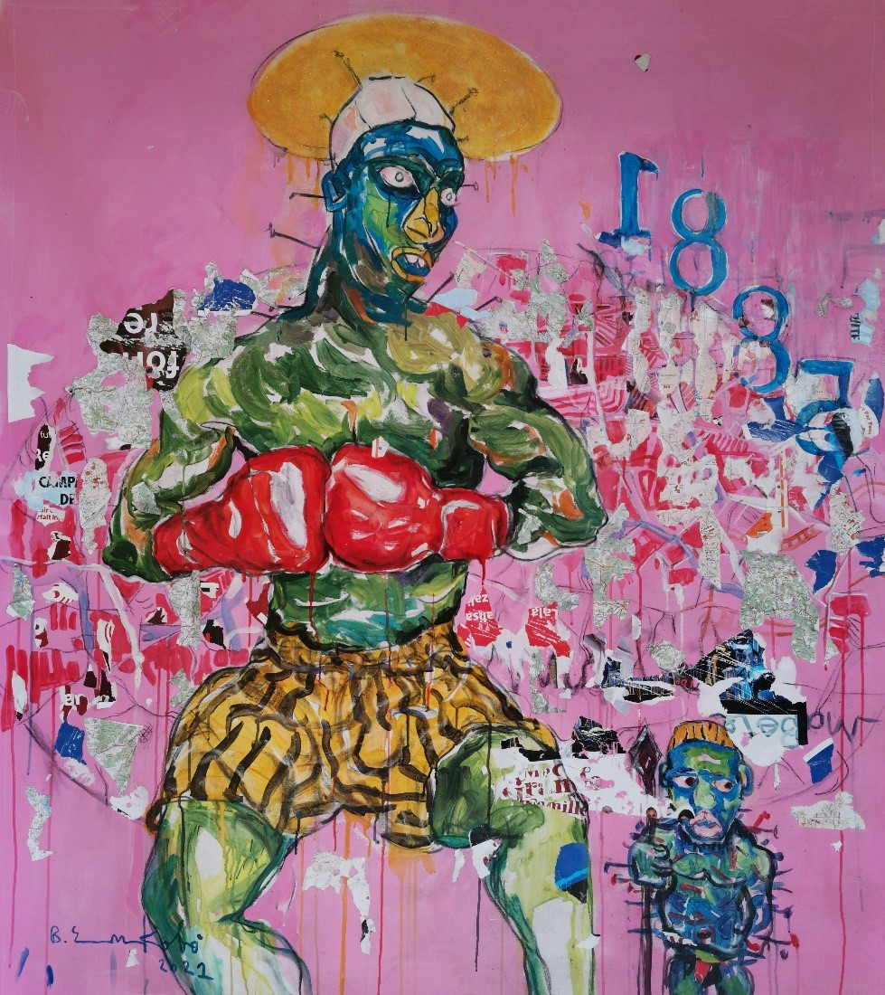
Bouvy Enkobo, Ntoto na beto 3 (Our earth 3), 2021, acrylic, collage and charcoal on canvas, 160x140 cm.

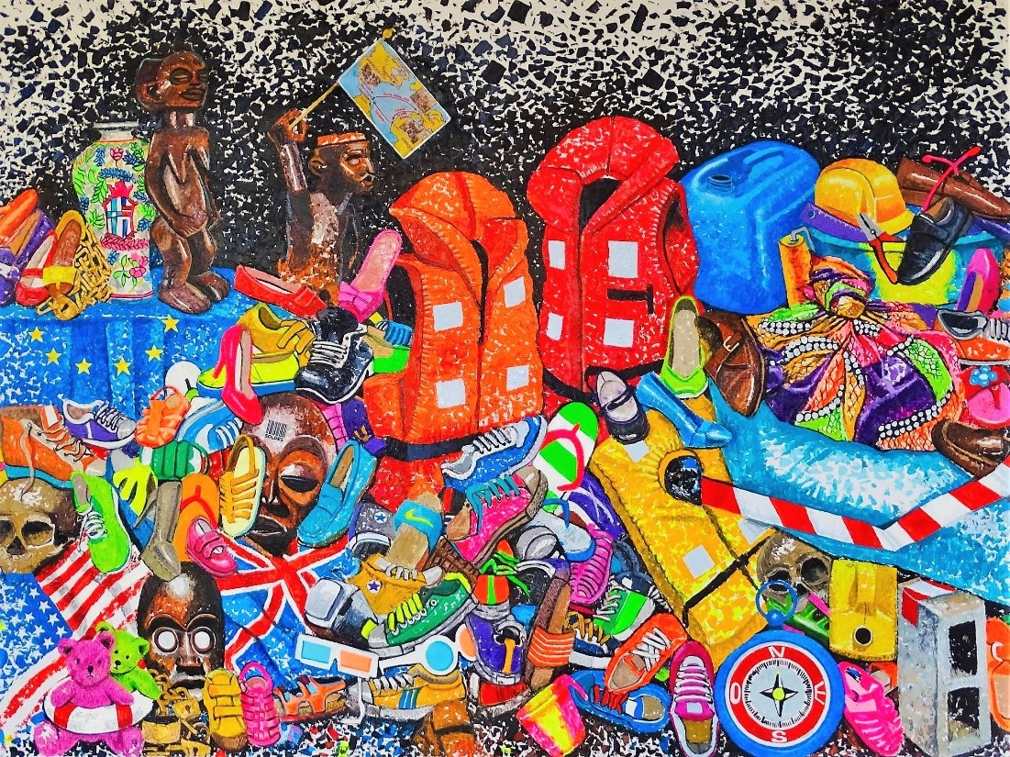
Jonathan Vatunga, Trace, 2021, acrylic and collage on canvas, 150x200cm.

Info

OpenArtExchange
Hoogstraat 85
3111 HC Schiedam
Email: info@openartexchange.com
Website: www.openartexchange.com
Facebook: https://www.facebook.com/openartexchange/
Instagram: https://www.instagram.com/openartexchange/

Opening hours
Wednesday to Saturday: 10:00 am – 6:00 pm
Sunday: 13:00 – 18:00

